Feedback.
Chithra guided and has asked to do Three OMS first and then Bhagwan’s prayer. The class went beautifully, except that children said my voice was crackling. We talked about how Ganesh was born, how Ganesh was given the head of an elephant, and what his part denotes.
1. Prayer for Bhagwan Baba
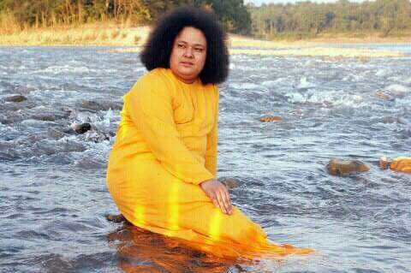
2. 3 Om
3. 3 Gayatri
4. Om Shanti Shanti Shanti
5. Ganesh Story
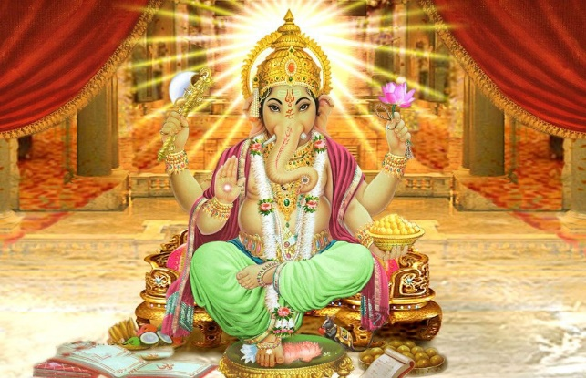
6. Song: Speak no evil speak only good, Hear no evil hear only good, See no evil see only good, Think no evil think only good. (will sing this song in later days)
Feedback: Chithra Amma sang a different song today. It was a song on Love All Serve All. Children were asked to sing individually.
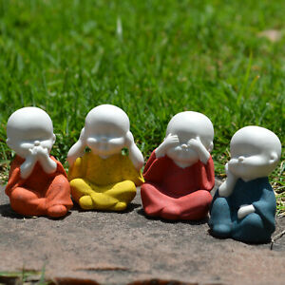
7. Game: Apna Haath Jagan Nath…Abraka dabra
Bird, Fish, Elephant, Butterfly, Mouse, Rama, Krishna, Jesus, Allah, Buddha
Feedback: Children were asked to make what came into their minds when these names were taken. Later they were asked to tell one nice thing when they thought of this name. At the end when asked what the best part in today’s class was, they said it was the game. Will repeat this game next week adding more items to it.
8.Karagrey Vasatey Laxmi

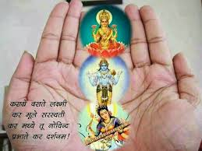
9. Omkara Bindu Samyukta
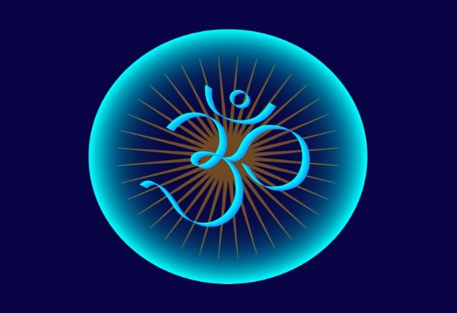
Feedback: We did the above-mentioned chanting and ended with three Omkara and three Shanti.
Om Shree Sai Ram.
10. Sarvessham Swasthir Bhavantu… Feedback: Still to teach the rest.
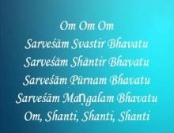
11. Kayena Vaccha…..
